HOME PAGE   
OM YATRA TOUR LOGO

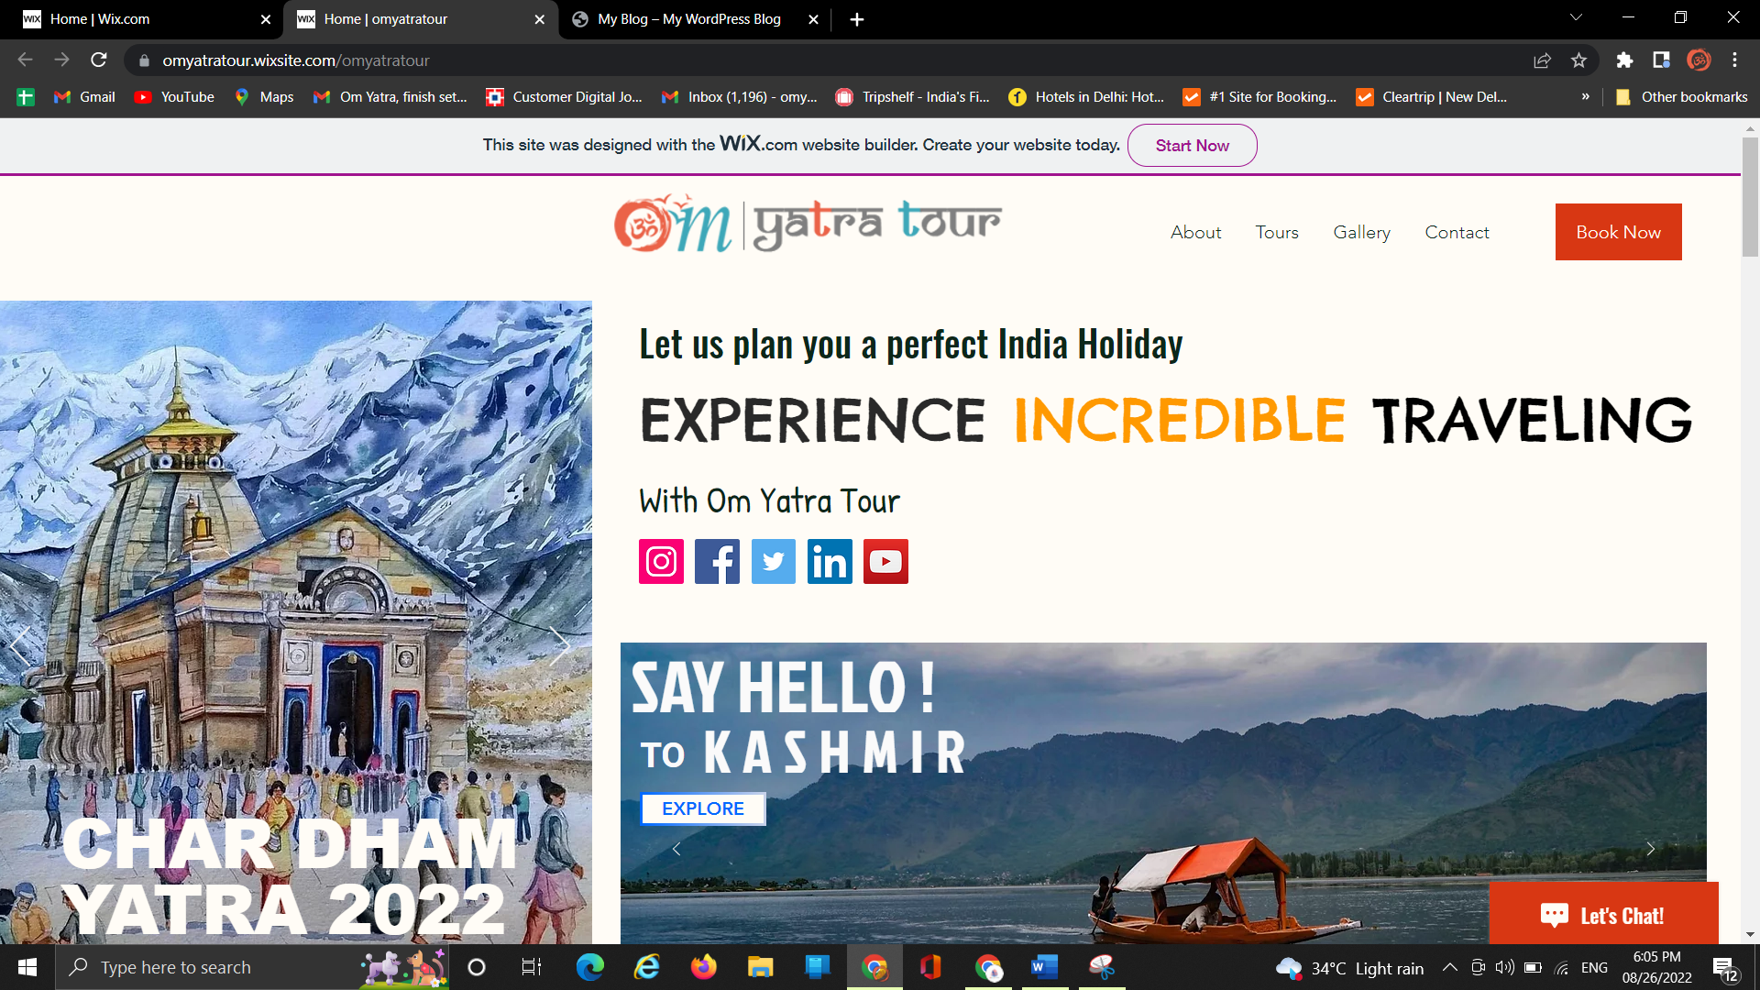

BOTH SIDE ARE WORKING WITH 3 YA 4 SLIDES

NEXT COLOUM FOR ABOUT INCREDIBLE INDIA  
  
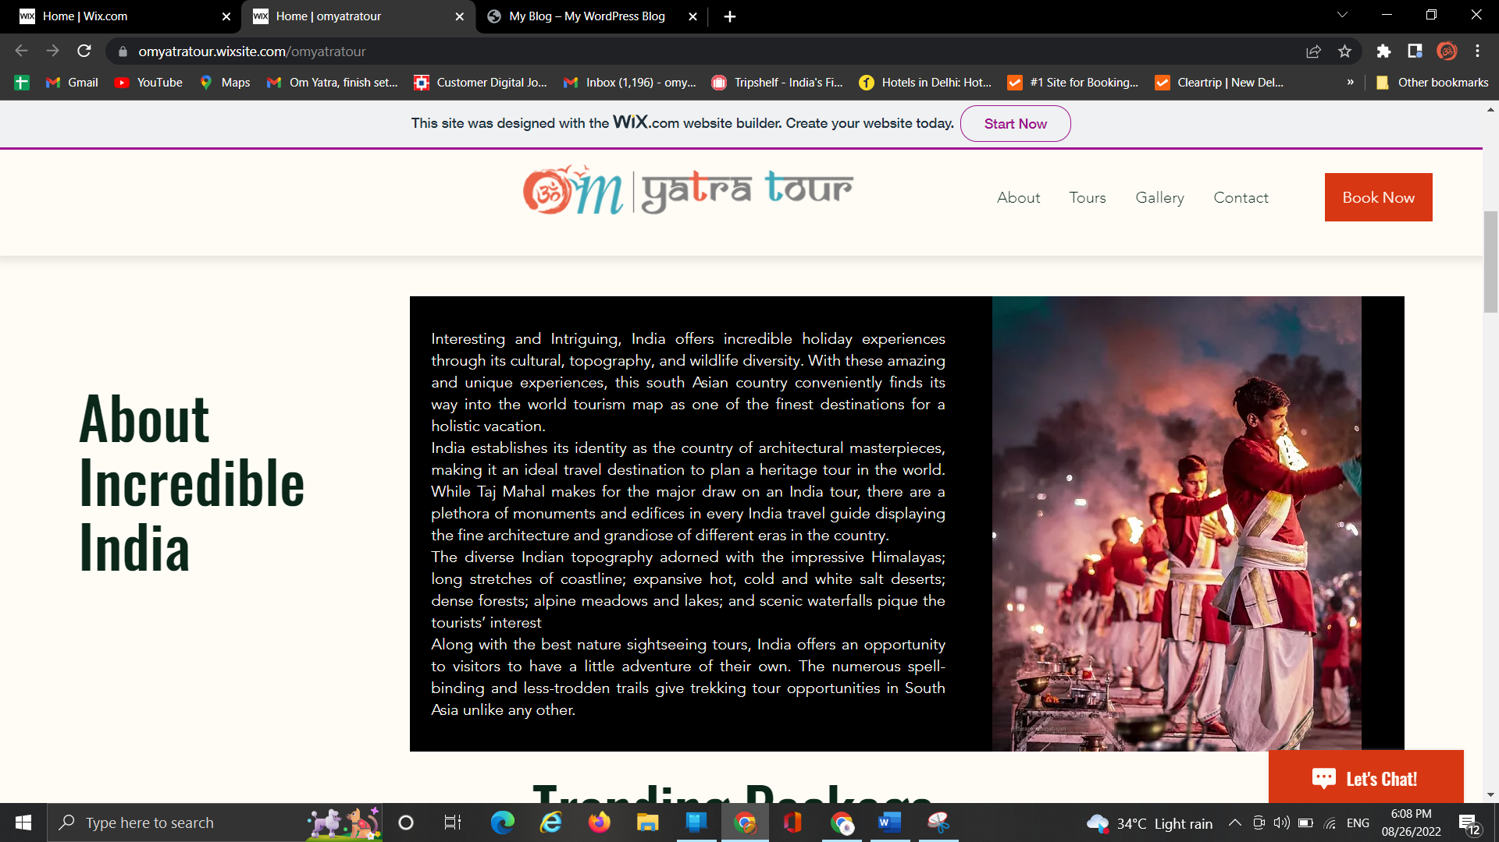  
  
TRENDING DESTINATION OF INDIA   
